**VOCABULARY**

* ____________________ – professional estimate of a property’s market value.
* ________________ – the date and time when the purchase of the house is finalized.
* ________________ – failure to repay a credit agreement.
* ___________________________ – paid by borrower which reduces that amount financed.
* ______________________ – the legal process by which the owner’s rights are terminated.
* ________________________ – a loan to finance the purchase of a house
* _______________________ – a written commitment from a lender that confirms the price of a home that a borrower can afford.
* __________________________________ – when lenders conduct business in ways that is illegal or not the best interest of the borrower.
* _____________________ – the money borrowed, not including interest and fees.
* ___________________________________________________________ – protects the lender and is usually required if you owe more that 80% of the mortgage.

**BENEFITS AND REALITIES OF HOME OWNERSHIP**

|  |  |
| --- | --- |
| **Benefits of Owing a Home** | **Realities of Owning a Home** |
|  |  |

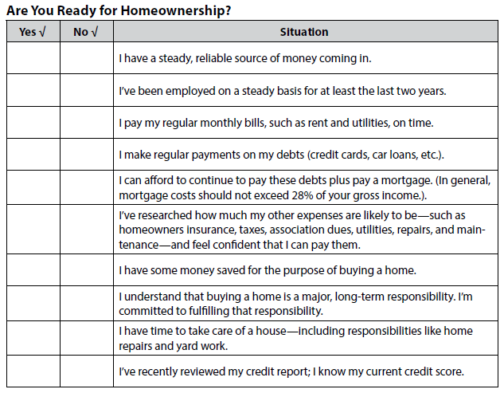

**LENDERS**

* Responsible Lender…
  + Puts everything in _________________
  + Gives you __________ to shop
  + An established company with a good _____________________
* Predatory Lender…
  + Encouraged to include ______________ information
  + Ads promise “_________________? ____________________”
  + Incomplete _________________ documents
  + Bi-weekly ___________________ payments
  + “Bait and Switch” _________________ Tactics

**STEPS OF THE HOME BUYING PROCESS**

* Make an ___________
* ____________________
* Go into ____________________
* Have a __________________inspection
* Get an __________________
* Receive _________________ approval
* Finalize the ____________________

**5 C’S OF CREDIT**

* __________________________________
* __________________________________
* __________________________________
* __________________________________
* __________________________________

**REASONS LOAN IS NOT GRANTED**

* ___________________ employment
* Poor or lack of ____________ history
* Too _______________ a time at residence
* ______________ of income
* Insufficient _____________________ payment

For each of the following situations classify as either **RENT, BUY, or DEPENDS**. Also, give reasons for your response.

1). Marla, age 22, plans to work full time while completing her college degree in a nearby city.

2) Bill, age 44, travels out of town frequently for his sales job. His company may transfer him to another sales territory within a year or two.

3) Kyle, age 32, recently completed his master’s degree in business while working at the same company for the past six years. He has also been able to save nearly $8,000 over this time period.

4) Jess, age 19, has just taken her first job as a sales representative for a computer software company.

5) Leslie and Frank, ages 54 and 57, are planning to retire within the next few years.

6) 8)

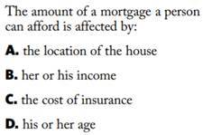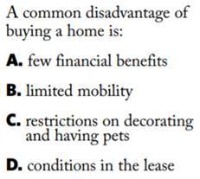

7. 9)

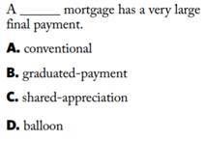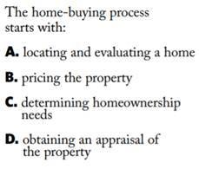

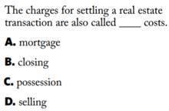10.